Name:

30
Vocab: Fiber chapter 6
- Use your textbook (p. 128-153) to define the following terms:
DO NOT USE internet sources
Fibers: ________________________________________________________________________________.
______________________________________________________________________________________.

Textiles: _______________________________________________________________________________.
______________________________________________________________________________________.

Fabric: ________________________________________________________________________________.
______________________________________________________________________________________.
Identify and draw the three basic weave patterns found in fabrics

______________________ | ______________________ | ______________________

Filaments: _____________________________________________________________________________.
______________________________________________________________________________________.

inorganic : _____________________________________________________________________________.
______________________________________________________________________________________.
______________________________________________________________________________________.
Examples:

Yarn : _________________________________________________________________________________.
______________________________________________________________________________________.

Warp:_________________________________________________________________________________.
______________________________________________________________________________________.

Weft or woof: __________________________________________________________________________.

Blend: ________________________________________________________________________________.
______________________________________________________________________________________.
______________________________________________________________________________________.

Draw the cross section shape of the following synthetic fibers

ROUND | TRILOBAL |  | DOGBONE OR DUMBELL |  | 4-LOBED
OCTALOBAL |  | IRREGULAR |  | MULTILOBAL
Polypeptide: ___________________________________________________________________________.
______________________________________________________________________________________.
______________________________________________________________________________________.

Homopolymers: _________________________________________________________________________.
______________________________________________________________________________________.
______________________________________________________________________________________.

Polyethers: ____________________________________________________________________________.
______________________________________________________________________________________.
______________________________________________________________________________________.

Density: ______________________________________________________________________________.
______________________________________________________________________________________.
______________________________________________________________________________________.

Becke Line: ____________________________________________________________________________.
______________________________________________________________________________________.
______________________________________________________________________________________.

Optical Brighteners: _____________________________________________________________________.
______________________________________________________________________________________.
______________________________________________________________________________________.

Chromatography: Separating chemicals (dyes) based on the elements they are made of. This can be done by using gasses, liquids, or solutions.

Chromatogram: _________________________________________________________________________.
______________________________________________________________________________________.

Elute: _________________________________________________________________________________.
______________________________________________________________________________________.
B________________________
A________________________
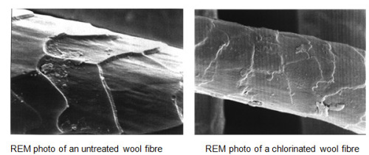
Warm-Up 1/3/18: What is this?
- Below is a microscopic image. Guess the identity of each picture? There are no right or wrong answers, so TAKE A GUESS!

