Name: Section:
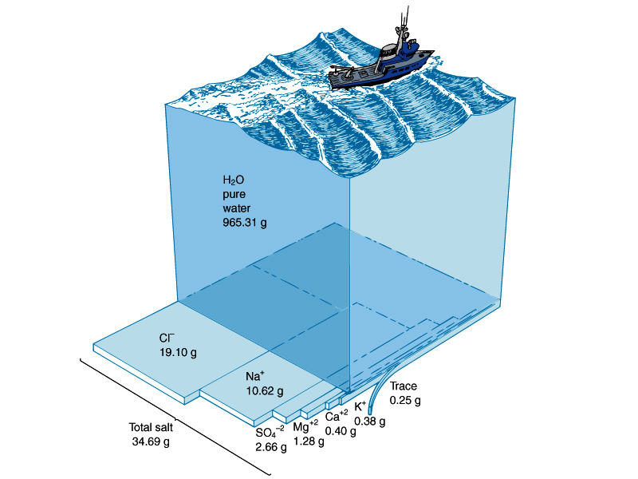
Properties of Ocean Water Unit
A. Composition of Ocean Water:
Ocean water is a __________________ of ___________
and ________________ dissolved in _______________________.
1. Gases:
2. Solids: _____% dissolved minerals like:
3. Disassociate into ions:
+
-
B. Salinity: __________________________________________________________________
Measured in _______________________________ (ppt or o/oo) (#g/1,000g = #g/L).
1. _____________ is the major salt in the world ocean.
2. _____________ is the second most abundant salt in the ocean.
3. The average salinity of the ocean is _______ ppt. Salinity ranges from _______ to ______ ppt depending
on evaporation and fresh water input.
4. Source of Salts: Where did the Oceans get their salt?
a/ ____________________ in the Oceans release H₂O, Cl⁻ and CO₂ Original oceans were _______________!
b/ ____________________ __________________________ of rocks release minerals Na, Mg, K, Ca
Rivers are _________________________ (________________).
c/ Billions of years ago…. Rivers (base) reacted with oceans (acid) in a _______________________________
reaction to form ___________________________________________!
d/ Salinity is currently ____________________________

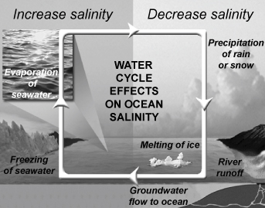
5. What factors influence the variations in salinity in the world’s oceans? Use diagram.
a/ Lower salinity occur where more fresh water enters the oceans.
1/ ____________________________________________________
2/____________________________________________________
3/ ____________________________________________ Seasonal.
4/ Groundwater flow to ocean
b/ Higher salinity occurs where fresh water is removed
and less fresh water enters the oceans .

1/ Hot oceans where there is little precipitation or runoff and a lot of ________________________.
2/ _______________________________________________ leaves behind ______________. Seasonal.
1
6. Salinity Profile (Variations with depth).
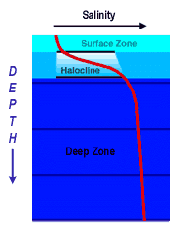
a/ Salinity _____________________ with depth.
b/ Salinity Layers:
1
1/Surface Zone:
2

2/Halocline:
3

3/Deep Zone:

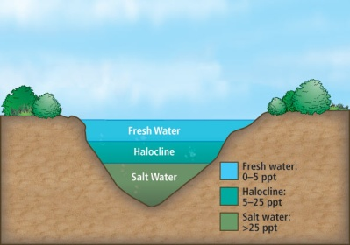
c. Salinity influences ocean water ________________________.

7. Sea Surface Salinity Use diagram to describe variation in surface Salinity across Earth’s Oceans.
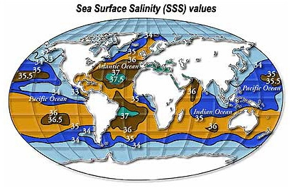
Equatorial (around 0º):
22ºN and S:
Polar (60-90ºN and S):
Mediterranean Sea:

1b
C. Ocean Temperature
1/ Ocean temperature varies with the amount of solar radiation received. The amount of solar radiation
received depends on _________________________ and ______________________.
2/ The temperature of the surface layer varies from ___________________ to _____________________.
3/ Sea water with an average 35 ppt salinity freezes at _________________________.
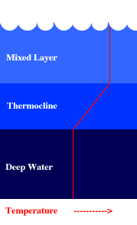
4/ Average Temperature of surface waters is __________________.
5/ Surface waters are warmer at the equator and colder at the poles.
6/ Ocean waters are warmer near the surface and colder with depth.
7/ Temperature Profile:

Mixed Layer(surface): ______________________________________________

__________________________________________________________
Thermocline: _____________________________________________________
__________________________________________________________

Deep water: ______________________________________________________
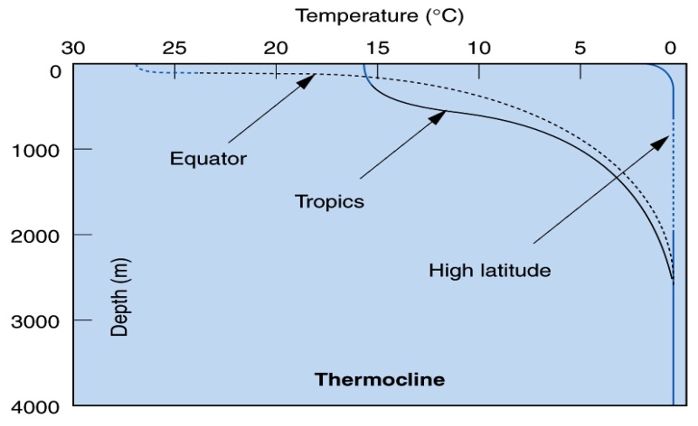
__________________________________________________________
8. The Thermocline
a/ Changes with latitude:

1/ ________________ at the Equator.

2/ ________________ or _____________________
at higher latitudes.

b/ The thermocline creates a barrier between kinds of marine life.
9. The Deep Layer is very cold!
a/ _______ of all Ocean water lies beneath the thermocline.
b/ The deep ocean layer is __________________ and consists of ________________________________.
c/ The deep layer is very cold all around the world ___________________________.
10. Satellite System - Argos
A system of _____________________________ at the surface _______________________ and
_________ over time __________________________________________ giving us __________________
on _________________________________________________ in the layers of the sea.
2
D. Sea Surface Salinity and Temperatures ANSWER Part D using this image
1/ At what latitude is sea surface temperature (sst) the highest?
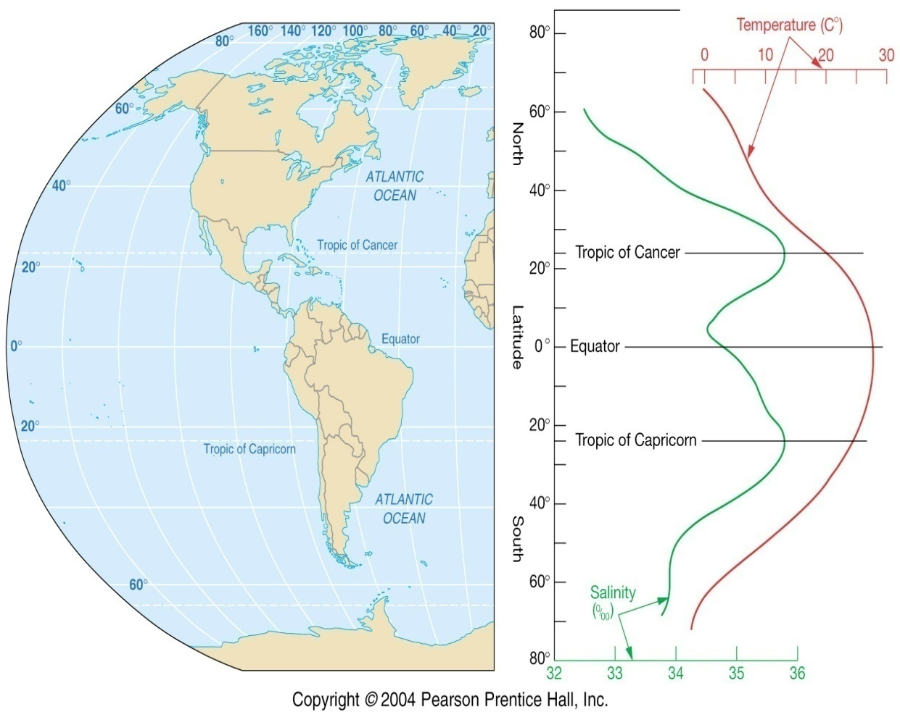
2/ At what latitude(s) are sea surface temperature (sst) the lowest?

3. At what latitude(s) are sea surface salinity (sss) the highest?
About what ppt?

4. Why isn’t the Equator the highest salinity?

5. Why are the highest salinities where they are?

6. Which polar region has the lowest salinity? Why do you think this is the case?

E. Density of Ocean Water
1. Density = _____________________________________________________________________________
2. Density of pure water is __________________________
3. The average density of ocean water is _______________g/cm³. It ranges from _________ to _________
4. Denser ocean water ______________!
5. Ocean water density depends on: _________________________________________________________
6/ Density of water is mostly determined by ____________________________.
7/ Cold water ______________. Warm water _________________.
8/ Density is also effected by _________________________.
Salty water is _______________ … _________! Less saline water is _________________ ... ___________
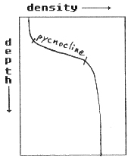
9/ Ocean Density Profile
a/ Density ________________________________________________________.
b/ _________________, __________________________water at surface and
____________________________ water in the Deep.
c/ The region of rapid density change is called the _________________________.
It acts as a __________________ between deep and surface waters.
2b
10/ Density in Polar Waters (High Latitudes)
a/ Cold, salty waters in the polar regions have _________________________________ pycnocline.
They start out dense and stay dense all the way down to the bottom.
b/ These waters ___________ to the deep zone driving _____________________________________!
They bring __________________ and _____________________ down with them.

F. Ocean Layers
1/ The _______________________, _______________________, and _________________________
are related and act as a ___________________between the Deep Zone and the Mixed-Surface Zone
of the ocean. This intermediate region is called the ________________________________________.
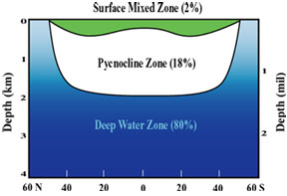
2/ Surface (mixed) Zone: _________________________________________
______________________________________________________________
______________________________________________________________
3/ Transition Zone: Located where _____________-, _________________-,
and ____________________________ occur.
Acts as a ________________________ between Deep and Surface Zone
______% Ocean.
4/ Deep Zone: ___________________________________________________
________________________________________________________________
________________________________________________________________
5/ High Latitudes (Polar): Little to no Surface or Transition Zones!
____________, _____________________ waters enriched with ___________________ _____________
to the ocean deep. This drives deep ocean circulation!

G. Case Studies:
1. Saltwater wedging in Estuaries like the Delaware and Chesapeake Bays.
2. Mediterranean Sea – underwater haline currents under the Mediterranean Sea and the Straits of
Gilbraltar.
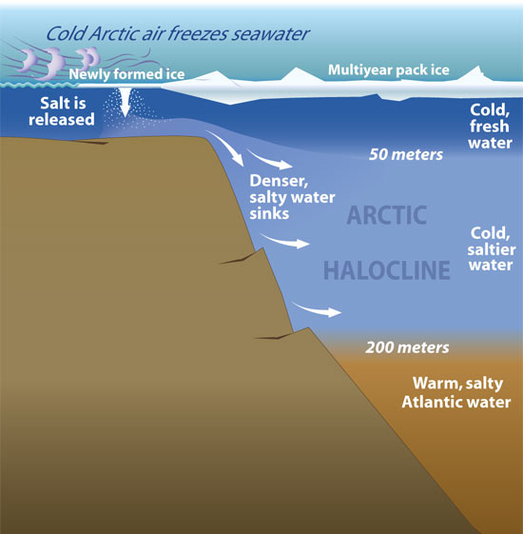
3. Polar haline currents drive deep sea currents.
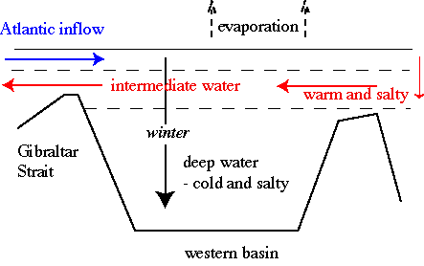
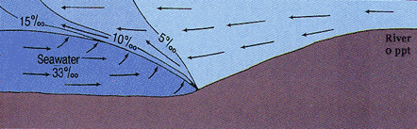
3
Halocline, Thermocline, and Pycnocline at Different Latitudes:
Doldrums:
Polar:
Horse Latitudes:
3b

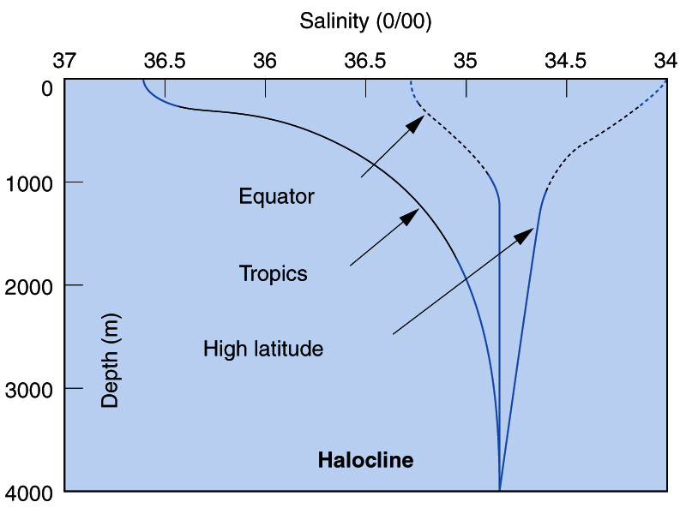
Melting Ice:

Freezing Ice:
Salinity is influenced by temperature, water input, and water output (freezing and evaporation).

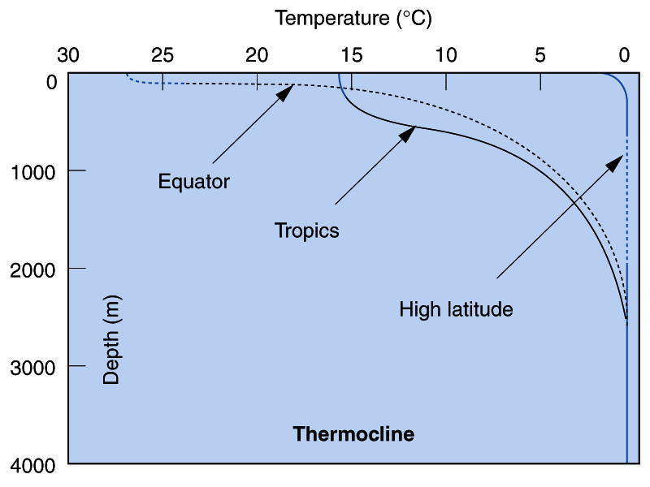

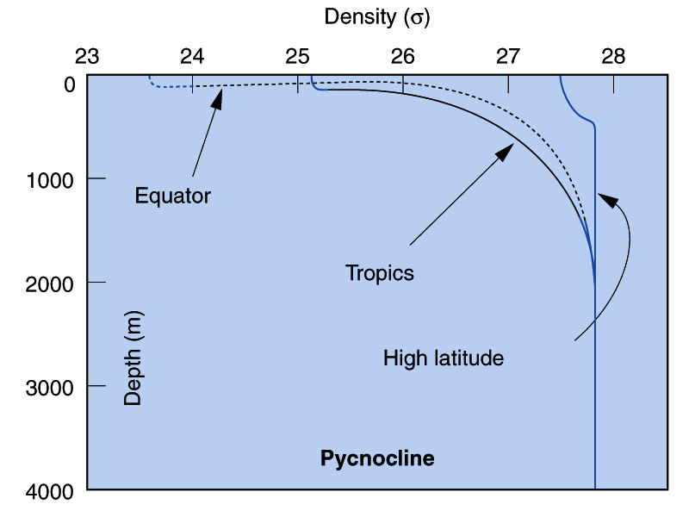

Polar:
Polar:
Temperature decrease with depth.
Density increases with depth.

Name: Section: Date:
Studying the Halocline at Different LatitudesKarcewski/Ocean1/2010
Plot the following salinity readings with depth for each of the following locations: Equator (0ºLat), Tropics (22ºN and S Lat), and High Latitude (70ºN Lat). When finished analyze and conclude. Use Red, Green, and Blue color pencils to draw lines.
Blue
High Latitude (70ºN Lat)
0’ = 34.0
100’ = 34.1
200’ = 34.2
500’ = 34.4
1000’ = 34.6
1500’ =
2000’ = 34.7
3000’ =
4000’ = 34.8

Red
Tropics (22ºN/S Lat)
0’ = 36.7
100’ = 36.6
200’ = 36
500’ = 35.6
1000’ = 35.2
1500’ = 35.1
2000’ = 35.0
3000’ = 34.9
4000’ = 34.8

Green
Equator (0ºLat)
0’ = 35.4
100’ = 35.4
200’ = 35.3
500’ = 35.1
1000’ = 34.9
1500’ = 34.8
2000’ = 34.8
3000’ = 34.8
4000’ = 34.8

On a lined piece of paper write out an analysis and possible explanation (summary) for each color line below. Make sure to use complete sentences and concepts learned/discussed in class.
1000
Depth in meters
34
Salinity 34 to 37 ppt
4000
3000
2000
1500
200
100
500
0
37
36
35

4
Salinity and Temperatures Profiles Name:
Ocean1 2010 Karcewski
Use the following depth profiles for salinity and temperature to answer the following questions.
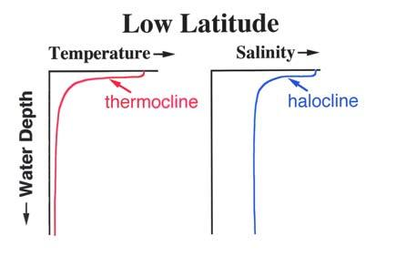
1/ What latitude is this? Is it near the Poles or Equator?
2/ How does the temperature change with depth?
3. How does the salinity change with depth?
4/ Why is the salinity greater at the surface?

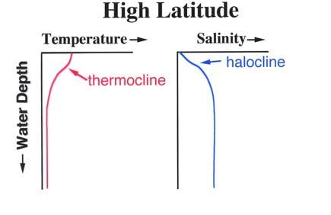
5/ What latitude is this? Is it near the Poles or Equator?
6/ How does the temperature change with depth?
7/ How does the salinity change with depth?
8/ Why is the salinity less at the surface?
9/ Looking at the thermo and halocline lines, what conditions do you observe that would lead to the
formation of an arctic ice cap?

10. How does the thermocline at higher latitudes compare to the thermocline at lower latitudes?

11. How does the Halocline at higher latitudes compare to the halocline at lower latitudes?

4b

