Name:
Case Study:
“Spy Assassinations: The Top 5 deadly poisons”

40
Directions:
To find the article online:
Google: Spy assassinations: The top 5 deadly poisons
Click on first link
- As you read the article, answer the questions.
- Internet Extensions: Some questions will require you to search the internet
for some information
.
The opening paragraph
- The opening paragraph of the article mentions a town in Britain, Salisbury. How many patients have been treated for exposure to an unknown nerve agent?

Polonium 210
- Who was involved in a Polonium poison case in London in 2006? What country was he from? How many days did it take him to die?
Internet extension #1:
List 5 countries that are capable of producing nuclear weapons and therefore capable of producing Polonium 210

- Who was allegedly responsible for the poisoning, how did they do it?

- Where/what is the main source of Polonium 210?
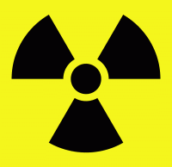

- Handling polonium. Is it safe? Would you be safe from polonium
radiation? If you were to place it a brown paper bag?

- For it to be dangerous to humans, what must a person do?

- How does polonium make someone sick? What does it do to the human body?

Ricin
- About how much is a lethal dose of Ricin?
Internet extension #2:
Ricin is extracted from the same plant from which we get castor oil. List one other interesting use for castor oil.

- What is ricin extracted from?
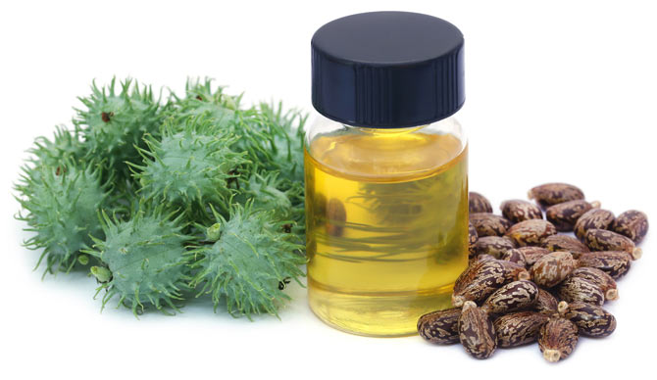

- Biologically Explain how ricin would kill a human.

Georgi Markov was a famous victim of ricin poison.
- How did he die?

- Who provided the poison? ________________________________
- Who ordered the assassination? ____________________________
- What was the motive
VX
Date of Assassination:
The Suspects
- Who are the suspects?

- Where are they from?

- What was their alibi?
Kim Jong Nam Assassination

Where did the assassination
Take place?

What country is the city in? Mark
It on the map Internet extension # 3

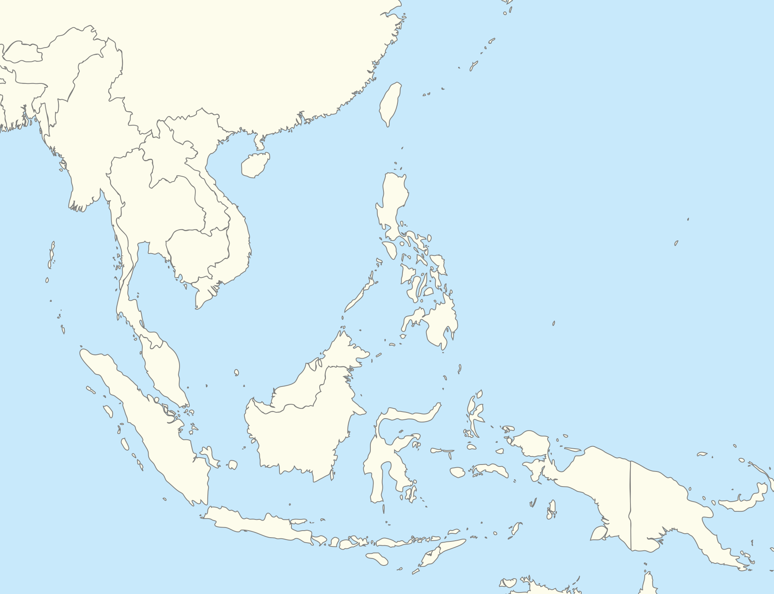

Who is Kim Jong Nam’s infamous half-brother? How is he involved in the assassination?

- What type of poison is VX. __________________ How much VX does it take to kill an adult_______________
- What were scientists researching when they discovered VX? _____________________________________
- What happened in 1997?

Botox
- What does Botox do to nerve cells?
Internet extension #4:
List 5 countries that are capable of producing nuclear weapons and therefore capable of producing Polonium 210

- As a result, what does it do to your body? List two.

- How much, or should we say how little, is a fatal dose? _________________

- What potential world threat does Botox have?

- Allegedly, the CIA had a plan to kill Fidel Castro. How did they plan to
expose Castro to the poison?

BTX
- 20. What is the full name of BTX? _____________________
Internet extension #5:
List 3 countries where you can find a poison dart frog in the wild.

- 21. Where does it come from? _______________________
- 22. What is the lethal does? _________________________
- 23. Read the caption under the picture of the poison dart
What interesting fact does it mention?

- How does the poison dart frog make its poison?
Spy assassinations: The top 5 deadly poisons
UK investigators have not yet confirmed what substance poisoned Russian double agent Sergei Skripal and his daughter in a shocking attack that has left them both in critical condition. DW looks at five possibilities.
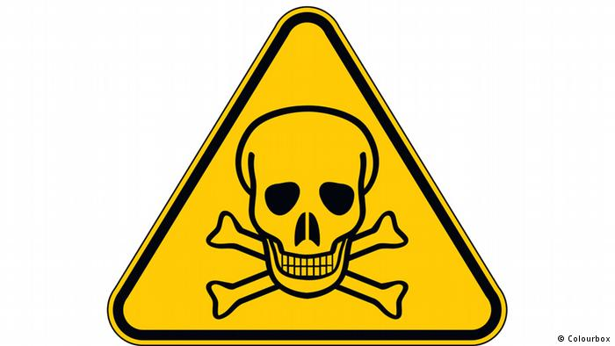
The number of patients treated for exposure to an unknown nerve agent in
the British town of Salisbury has risen to 21, but officials have not yet
confirmed exactly what substance they found. Here are the top five substances
political regimes have used in the past — or might use — to eliminate
adversaries or traitors.

Polonium 210
Russian agents used the radioactive element to poison former FSB agent Alexander Litvinenko in London in 2006, say British investigators. Former Russian intelligence colleagues reportedly poured the substance into his tea. 23 days elapsed between the day when he was hospitalized and his death.

Polonium 210 cannot be bought on the market and is almost impossible to detect if the investigation starts too late. It has a half-life of 138 days. In nature, it only appears in marginal quantities as a product of radioactive decay.

The world's nuclear powers are the only countries able to produce polonium in quantities that could be used to kill. In order to produce the lethal dose of 100 nanograms, one would need several hundred kilograms of raw uranium ore. In a nuclear reactor, one could generate polonium by bombarding bismuth with neutrons.

Handling polonium, however, is not very dangerous. The element is a strong ionizing alpha emitter. When sealed in any packaging, it is actually rather safe. The radioactivity will not even penetrate a sheet of paper. However, if inhaled or ingested it damages the stomach lining, destroys leukocytes in the blood and results in anemia. It also destroys stem cells and prevents them from multiplying. Victims die within a few days or weeks.

Ricin
Ricin is one of the most dangerous poisons in the world. Just a few milligrams of the naturally-occurring, carbohydrate-binding protein are enough to kill someone when injected, swallowed or inhaled. It can be extracted from the seeds of the castor oil plant Ricinus communis.

Once in the body, ricin prevents the production of essential proteins. As a result, the central nervous system, kidneys, liver and other organs will fail. Death by multiple organ failure or cardiovascular shock will occur within a few days.
Markov was publishing unpleasant details about communist leaders when he was poisoned with ricin

Ricin became famous in the Georgi Markov umbrella murder case.
A Bulgarian communist agent fired a tiny bullet with the substance
into the defector's leg in 1978 in London; Markov died three days
later.

Investigators at the time suggested that the Soviet agency KGB
may have provided the poison.

It has been alleged that Bulgarian dictator Todor Zhivkov ordered the assassination of the writer, because Markov published biting details about the top circles of the communist regime. His sarcastic broadcasts on western media, including the BBC, RFE and DW, were popular with listeners in Bulgaria.

VX
More recently, on February 13, 2017, two women sprayed the nerve agent VX into the face of Kim Jong Nam, killing the half-brother of North Korea's dictator, Kim Jong Un. The assassination took place at the Kuala Lumpur International Airport. Kim Jong Nam died on the way from the airport clinic to another hospital shortly after the attack.

The two women were from Vietnam and Indonesia and claim that they did not know that the spray included the nerve agent and that they were made to believe that they were part of a candid-camera prank. Investigators believe that Kim Jong Un ordered the assassination.

VX is the most dangerous known chemical nerve agent. Just 0.4 milligrams of the substance is enough to kill an adult.

Chemist Ranajit Gosh discovered the substance in the 1950s when researching on pesticides in the laboratories of the British Imperial Chemical Industries.

A related substance called VG was used as a pesticide under the name Amiton — but only for a short period. During the Cold War, the United States started mass producing VX. The Soviet Union produced a related nerve agent known as "Russian VX."

The nerve agent has been banned under the 1997 Chemical Weapons Convention. North Korea is not a signatory.

Other historic incidents in which VX was used include the 1988 mass killing of roughly 5,000 Kurdish civilians by the forces of Iraqi dictator Saddam Hussein in the town of Halabja. And in the early 1990s Japanese sect leader Shako Asahara synthesized VX and killed one victim with the substance. He later committed the 1995 subway terror attack with another nerve agent, Sarin, killing 13 people and injuring more than 1,000.

Botox
The poison, produced by Clostridium Botulinum, is mainly known for its cosmetic application. However, the botulism toxin is the same one responsible for food poisoning. The bacteria is ubiquitous, but can only develop and multiply in an environment without oxygen. That's why it occurs in spoiled salami. Botox is similar to the toxin at work in a tetanus infection.
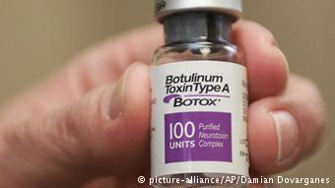

It is a neurotoxic protein, which blocks the transmission of
signals by the nerve cells. This results in a paralysis of the
vegetative nerve system and muscle weakness.
Just 0.3 micrograms of Botox can be fatal.

Botox is considered a potential biological weapon. The main
concern is that it could be used in bioterrorism. Iraq under Saddam Hussein had a program for producing Botox as a weapon of war.

According to Cuban secret service head Fabian Escalante's Book "Executive Action", the CIA or Cuban exiles had at one point hatched a plan to kill Fidel Castro with a Botox-contaminated cigar. The existence of the alleged plan cannot be independently confirmed.

BTX
Batrachotixin is another extremely powerful neurotoxin. It is a steroidal alkaloid produced by poison dart frogs, an endangered species native to Latin America. Just 0.2 grams are enough to kill a human. The toxin causes arrhythmias and ventricular fibrillation in heart muscles, resulting in a cardiovascular arrest.

It is not possible to keep poison dart frogs in captivity and then produce the toxin, however. Only in their native habitat in the Central and South American rainforests are the animals able to produce the toxin. It is believed that the frogs can only develop the poison as a result of digesting certain beetles and insects.

Thousands of the frogs would be needed to produce enough BTX to kill a human. However, there are no known cases of human poisoning by BTX.

